**BizTalk Migration Tool - User Guide**

**Overview**

BizTalk Migration Tool simplifies manual effort in migrating artifacts from one source to destination BizTalk platform. Tool has been tested to migrate artifacts from BizTalk Server 2010 to 2013 R2 and from BizTalk 2013 R2 to 2016 versions.

It comes with few inbuilt intelligence like

* Connectivity test of source and destination SQL Instance or Server
* Identify BizTalk application sequence
* Retain file share permissions
* Ignore zero KB files
* Ignore files which already exist in destination
* Ignore BizTalk application which already exist in destination
* Ignore Assemblies which already exist in destination
* Backup all artifacts in a folder.



|  |  |
| --- | --- |
| Features Available | Features Unavailable |
| * Windows Service * File Shares (without files) + Permissions * Project Folders + Config file * App Pools * Web Sites * Website Bindings * Web Applications + Virtual Directories * Website IIS Client Certificate mapping * Local Computer Certificates * Service Account Certificates * Hosts * Host Instances * Host Settings * Adapter Handlers * BizTalk Applications * Role Links * Policies + Vocabularies * Orchestrations * Port Bindings * Assemblies * Parties + Agreements * BAM Activities * BAM Views + Permissions | * SQL Logins * SQL Database + User access * SQL Jobs * Windows schedule task * SSO Affiliate Applications |

**User Guide**

1. Either compile the Migration tool using the GitHub files, or go to:

<https://blogs.msdn.microsoft.com/biztalk_server_team_blog/2017/06/28/announcing-biztalk-server-migration-tool/>

to download an msi for the migration tool.

Once MSI is installed in your local machine, the folder structure appears as shown below:



1. Right click and run MigrationTool.exe as an Administrator. The tool appears as shown below:

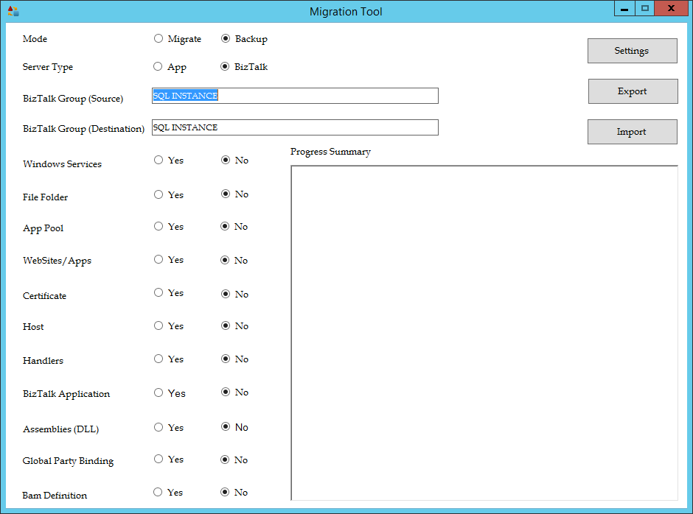

1. Before starting with export and import feature of this tool, please verify the tool settings by clicking “Settings” button (visible on top right corner). The screen appears as shown below:

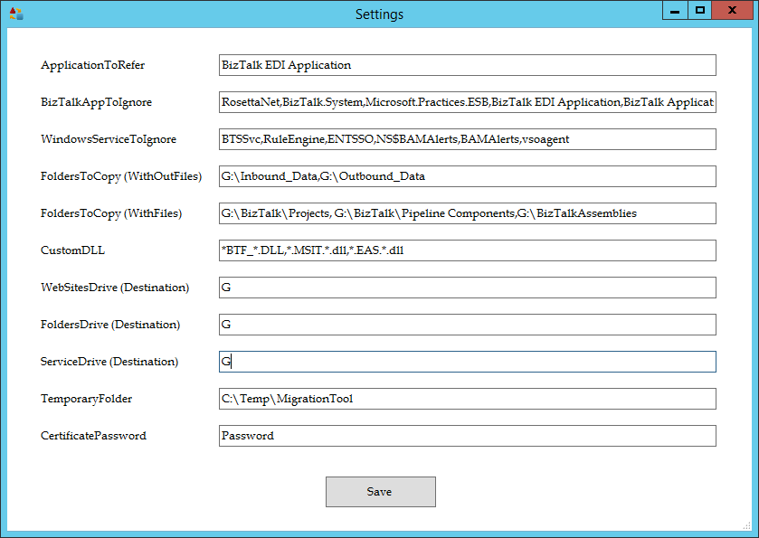

Please check tooltip on each label for more information. Modify the values in each textbox as per your environment and click on “Save” button.

1. Once Tool Settings is verified, select Mode as either Migrate or Backup.

The purpose of Migrate – is to lift/shift artifacts from a source to a destination server.

The purpose of Backup – is to extract artifacts from a source and save it in a folder for future use.



Select Server Type as BizTalk – to lift and shift all BizTalk artifacts (as listed in below table).

Select Server Type as App – to lift and shift all Web or Application Server artifacts.

|  |  |
| --- | --- |
| Type as BizTalk | Type as App |
| * Windows Service * File Shares (without files) + Permissions * Project Folders + Config file * App Pools * Web Sites * Website Bindings * Web Applications + Virtual Directories * Website IIS Client Certificate mapping * Local Computer Certificates * Service Account Certificates * Hosts * Host Instances * Host Settings * Adapter Handlers * BizTalk Applications * Role Links * Policies + Vocabularies * Orchestrations * Port Bindings * Assemblies * Parties + Agreements * BAM Activities * BAM Views + Permissions | * Windows Service * File Shares (without files) + Permissions * Project Folders + Config file * App Pools * Web Sites * Website Bindings * Web Applications + Virtual Directories * Website IIS Client Certificate mapping * Local Computer Certificates * Service Account Certificates * Assemblies |

1. Enter the source and destination BizTalk server details.

SQL Instance name – please enter BizTalk Management DB SQL Instance name.



1. Select the features which we need to migrate from a source to destination server.

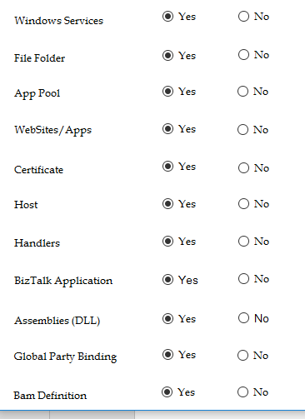

1. Select the source server from dropdown and click “Export” button.



1. During Export two new folders gets created “ExportedData” and ‘Logs”.



1. ExportedData folder contains the actual data exported from the source server.



CERT - Certificates gets exported to this folder.

CUSTOM DLL - Custom Assembly gets exported to this folder.

DLL - BizTalk Assembly gets exported to this folder.

File Folder - All folder mentioned in Tool Settings gets exported to this folder.

MSI - BizTalk application MSI gets exported to this folder.

VDir - Web Application + Virtual Directories gets exported to this folder.

XML files - Various XML files used by the tool gets exported to this folder.

1. Logs folder contains details log file.



1. Go through Progress Summary window to understand status of each export operation.



1. Once “Export” is successful, select destination server from the dropdown and click on “Import” button.



1. Go through Progress Summary window to understand status of each import operation.

